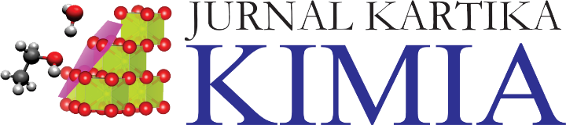

**TRANSFER OF COPYRIGHT AGREEMENT**

*Must be signed and returned to the editor-in-chief of the journal before the manuscript can be considered for publication*

The transfer of copyright from author to publisher must be clearly stated in writing to enable the publisher to assure maximum dissemination of the author’s work. Therefore, the following agreement, executed and signed by the main author or corresponding author, is required with each manuscript submission.

1. **Parties of the Agreement**

Author (s):

The article entitled

(Herewith referred to as the "Materials"),

is herewith submitted for publication in

**“Jurnal Kartika Kimia”**

(JKK)

**2. Subject of the Agreement**

**A) Copyright**

1. The Author and each co-authors transfer the copyright and grant the journal right of publication with the work simultaneously licensed under an International Creative Commons Attribution and ShareAlike 4.0 License that allows others to share the work with an acknowledgement of the work's authorship and initial publication in this journal.
2. Authors are able to enter into separate, additional contractual arrangements for the non-exclusive distribution of the journal's published version of the work (e.g., post it to an institutional repository or publish it in a book), with an acknowledgement of its initial publication in this journal.
3. Authors should sign copyright transfer agreement when they have approved the final proofs sent by JSL prior the publication.

**B) Author Guarantee**

1. The Author (Co-authors) guarantees that the Materialsare an original work, submitted only to JKK, and have not been published previously.
2. In case the Materials were written jointly with Co-authors, the Author guarantees that he/she has informed them of the terms of this Agreement and obtained their signatures or written permission to singe on their behalf.
   1. The Author guarantees as well that: The Materials do not contain libelous statements.
   2. The Materials do not infringe on other persons' rights (including without limitation copyrights, patent rights and the trademark right).
   3. The Materials do not contain facts or instructions that can cause damage or injury to third parties and their publication does not cause the disclosure of any secret or confidential information

**Author** (Corresponding Author):

Correspondence Address:

Phone:

Fax:

Email:

Corresponding Author: Surname; First name Signature Date

**On Behalf of the Publisher:**

Department of Chemistry,

Faculty of Sciences and Informatics (FSI),

Jenderal Achmad Yani University (Unjani)

Cimahi 40531, Indonesia

Telp/Fax: +62-22-6631556

Email: [jkk@kimia.unjani.ac.id](mailto:jkk@kimia.unjani.ac.id)

Website: <http://jkk.unjani.ac.id/index.php/jkk/index>

**Accepted for publication** 🗹 Signature Date

PLEASE NOTE:

The accepted manuscript cannot be processed for publication until the publisher has received this signed form. If the manuscript is not published in the Journal, this release will not take effect.

The sole responsibility for the whole content (s) of the article remains only with the corresponding author. However, Editor would reserve the right to adjust the style to certain standards of uniformity before publication.